COMSATS UNIVERSITY ISLAMABAD,

ATTOCK CAMPUS

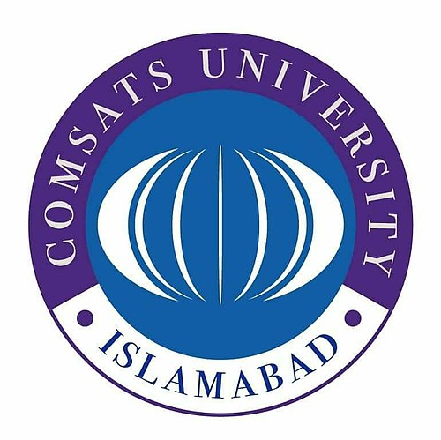
Submitted by:- M. Haider Iqbal
Submitted to:- Ms. Ambreen Gul
Registration #:- SP24-BSE-039
Date:- 14-Oct-2025

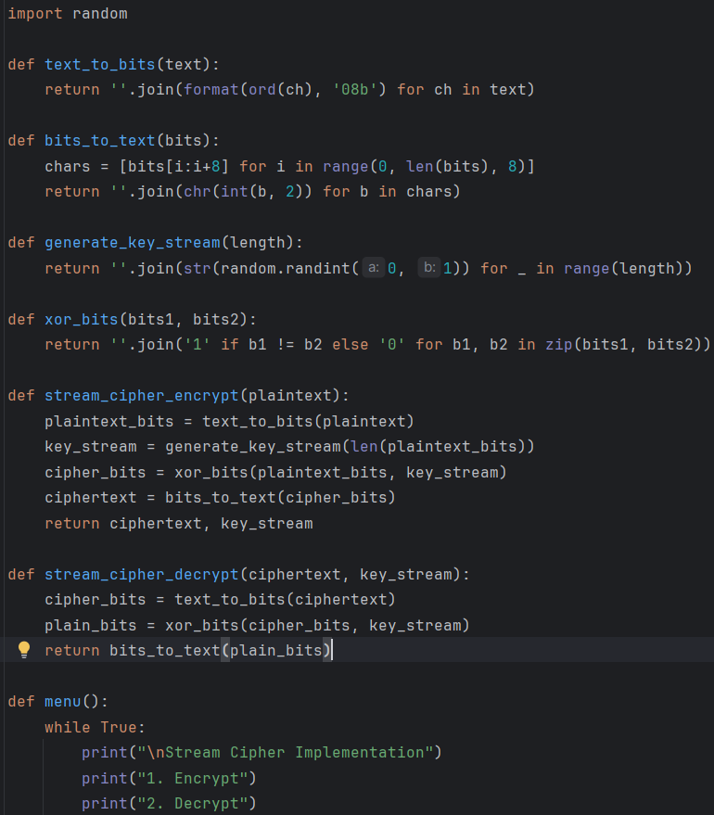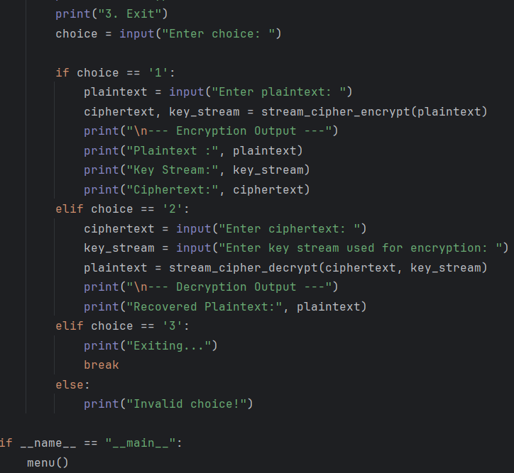

OUTPUT
